All Sample run file are uploaded along with source file in [crypto_api_test_automation.zip](https://github.com/leena2208/crypto/blob/main/crypto_api_test_automation.zip)

After executing the code three test report files, snapshots & log files get generated.

1. Final_test_report_.csv located under test-> api -> report folder

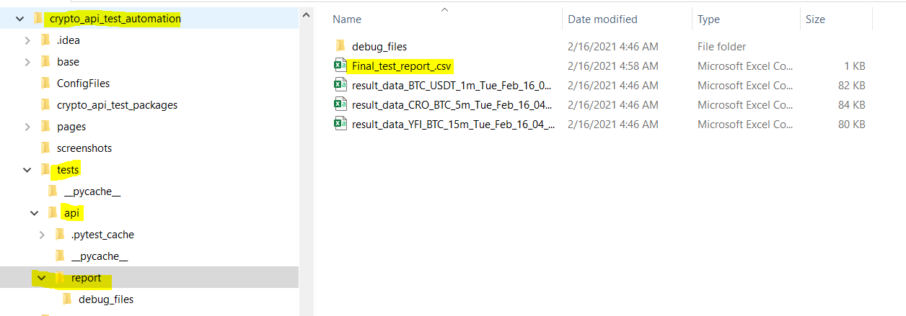

This report contains the details of test cases and its Pass/Fail status.

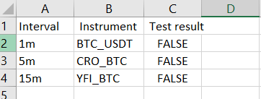

This file has two status of test:

Fail : when O, H, L & C values of any of the candle fetched from get-candlestick does not match with trade corresponding trade values.

Pass: when l O, H, L & C of all candle matches with the trade data obtained for that interval.

1. One detailed test report gets generated for each entry in testdata.csv and these files are located under test-> api -> report folder.

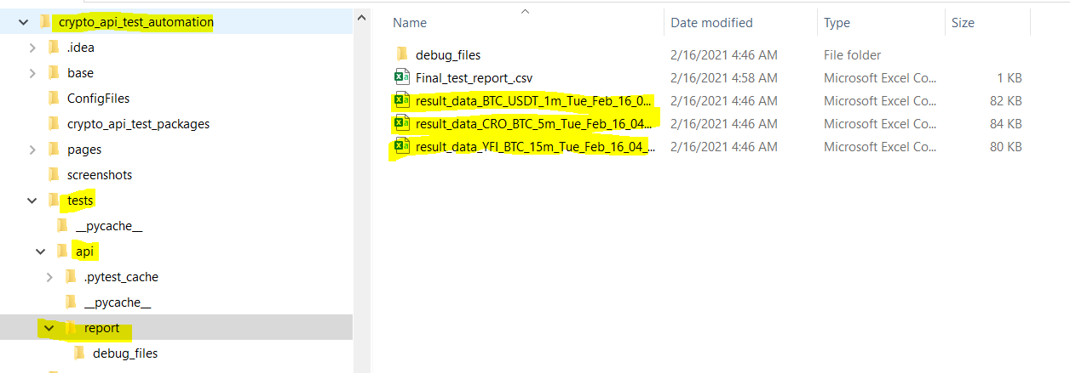

result_data_BTC_USDT_1m_Timestamp.csv

result_data_CRO_BTC_5m_Timestamp.csv

result_data_YFI_BTC_15m_Timetamp.csv

More details of result_data_CRO_BTC_5m_Timestamp.csv:

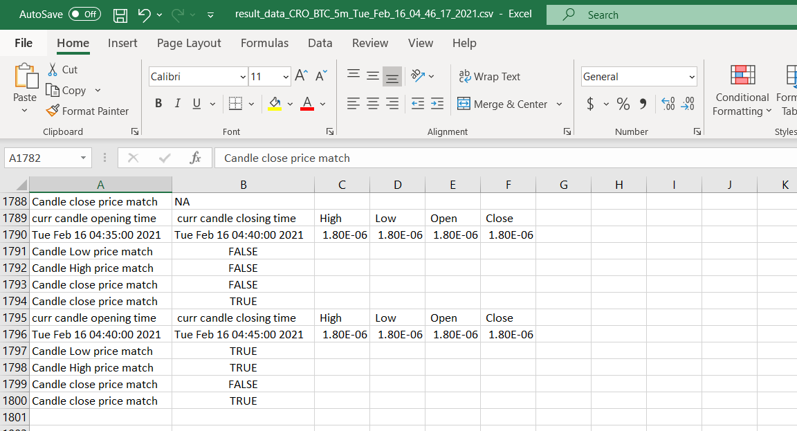

Each file contains test status for every candle fetched from get-candlestick api. Ths file has three status.

Pass : when the data fetched from get-trade api matches with data fetched from gt-candlestick api.

Fail : when the data fetched from get-trade api does not match with data fetched from gt-candlestick api.

NA : When the trade data obtained from get-trade api does not have any trade falling in the range of candle. [Because the api provides limited results even after using limit & offset options]

1. Other files are for debug purpose.

The framework generates Candle data file for every candle checked during testing and this files are located under test-> api->report->debug_files

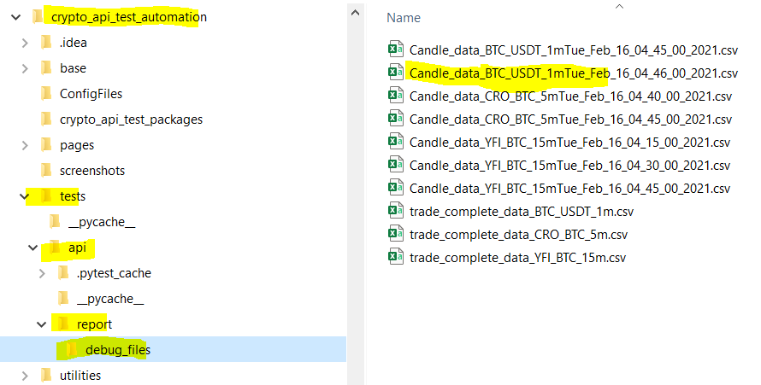

Candle_data_instrument_interval_close_time_of_candle.csv

In below file the row 2 & 3 are data from get-candlestick api and data in row 4 onwards are fetched using get-trades api. This file given details related to particular candle. E.g. In below example we are looking st the candle with closing time of Tue Feb 16 04:40:00 2021.

Column C, row 2& C, row 3 are same and denoted High value for current candle.

Column D, row 2& D, row 3 are same and denoted Low value for current candle.

Column E, row 2& E, row 3 are same and denoted Open value for current candle.

Column F, row 2& F, row 3 are same and denoted Close value for current candle.

Column C row 4 to Column C row 21 denoted trade price for all trades executed during candle duration.

Column B row 4 to Column B row 21 denoted time stamp for all trades executed during candle duration.

Column A row 4 to Column A row 21 denoted Unix time stamp or all trades executed during candle duration.

Column D row 4 to Column D row 21 denoted volume all trades executed during candle duration.

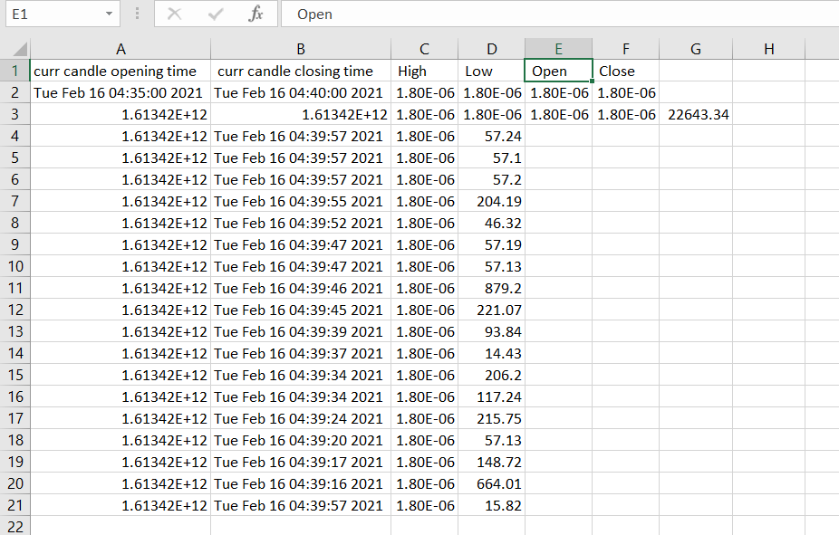

1. Apart from above test data files, whenever the test fails the framework take snapshot of webpage and store it to Screenshot folder:

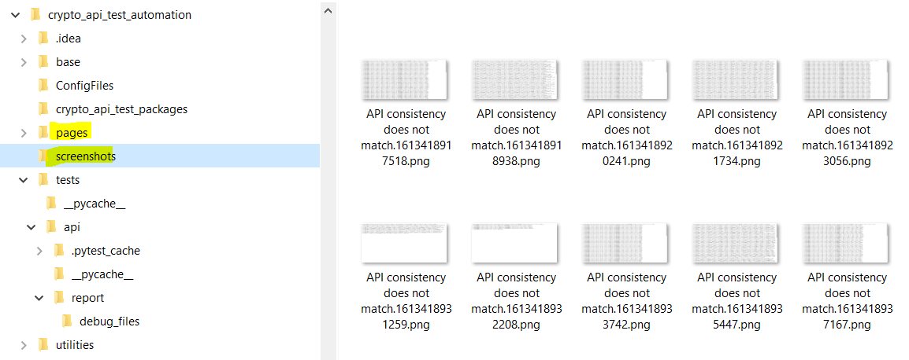

1. Log file for test steps is stored in test->api folder

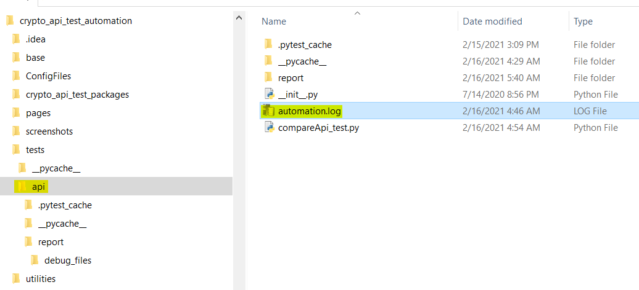

And we have Trade data file that contains all trades fetched from get-trade api.

And this file is located under api -> report -> debug_files

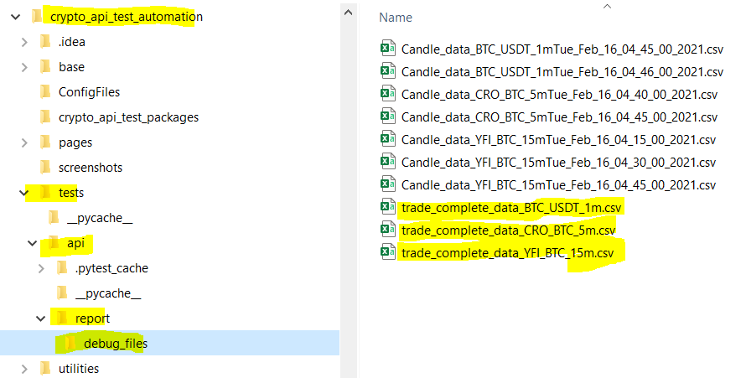

Column B denotes time stamp for all trades executed during for specific instrument.

Column A denoted Unix time stamp or all trades executed for specific instrument.

Column C denoted trade price for all trades executed for specific instrument.

Column D denoted volume all trades executed for specific instrument.

